Phase 2
API Security Testing

Objective
The Goal of this assessment to identify security weakness/vulnerabilities in the DVWA/API like components in accordance to OWASP top 10 methodology. Testing issues like BOLA, Weak session token validation, missing rate limiting and SQL injection. These vulnerabilities allow unrestricted access to data and accounts which are not supposed to be accessed by unauthorized adversary.

Tools used
- Burp suite
- SQLmap
- Kali-Linux
- Metasploit 2 VM

Methodology
- API Endpoint Enumeration
Using Burp suite we were able to intercept all DVWA traffic, revealing API like GET and POST request for authentication , SQL injection , brute force and input reflection functions.
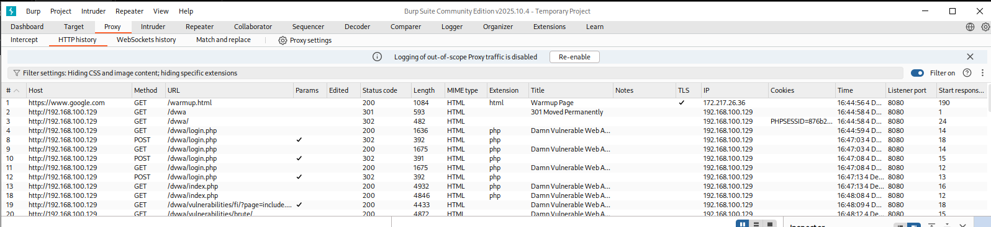

- Authentication testing
While testing we were able to observe that the we are able to steal the PHPsession cookies from logged in account and take over the session.
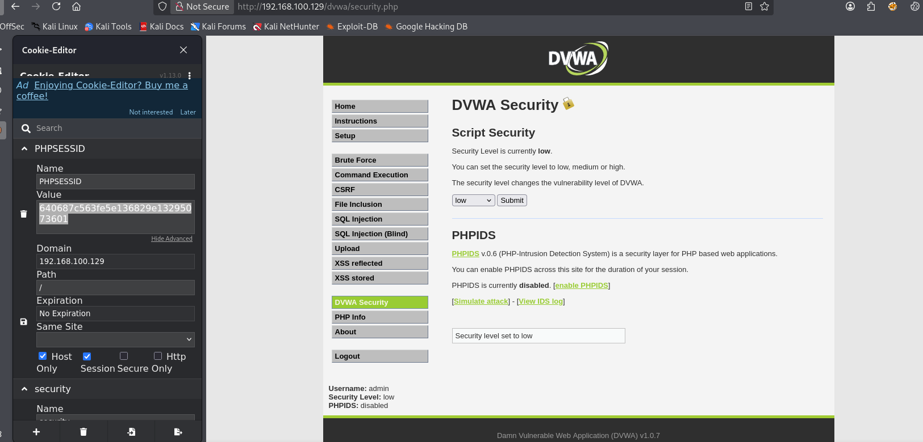
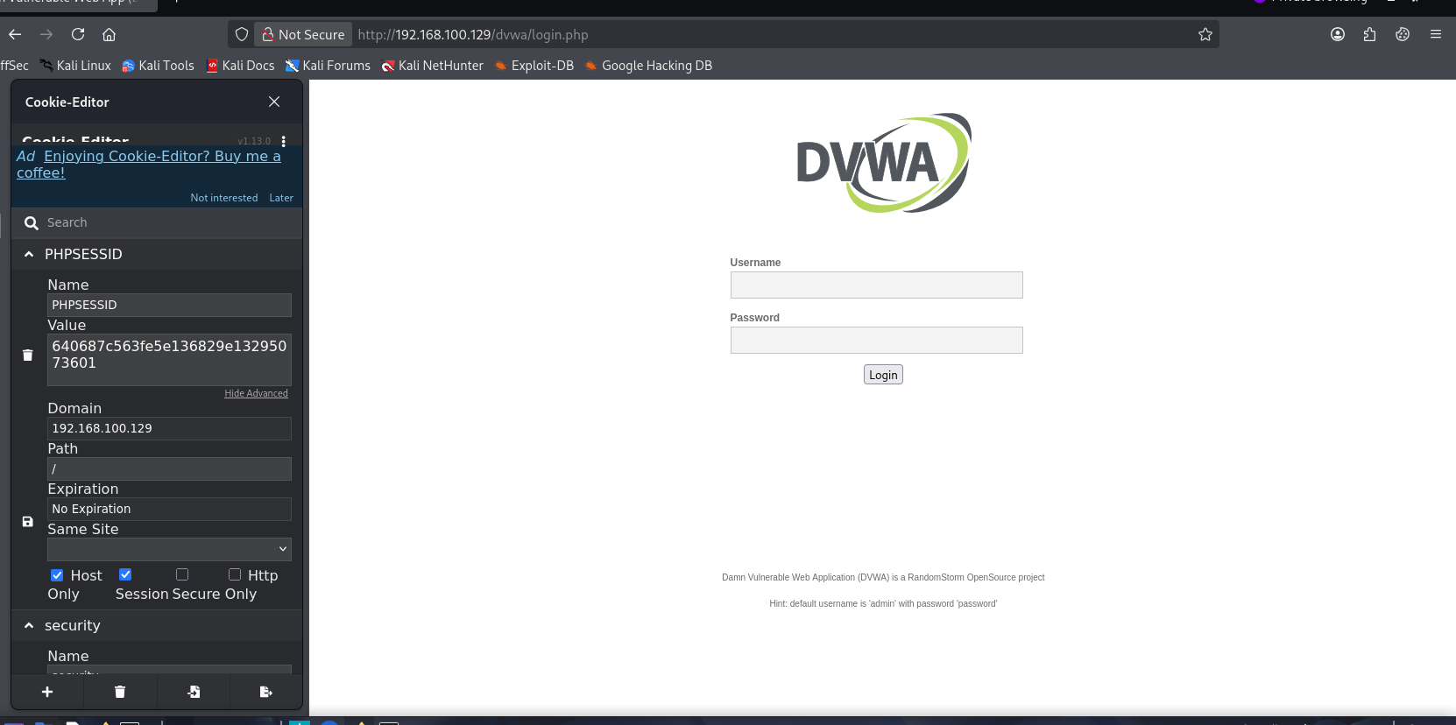
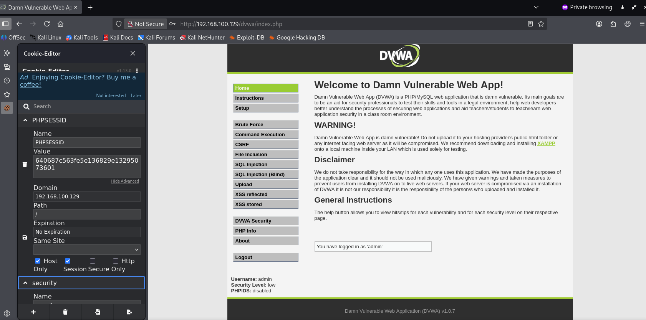

- Authorization Testing (BOLA)
We can enumerate other users records without permissions by changing the parameters in /vulnerabilities/sqli/
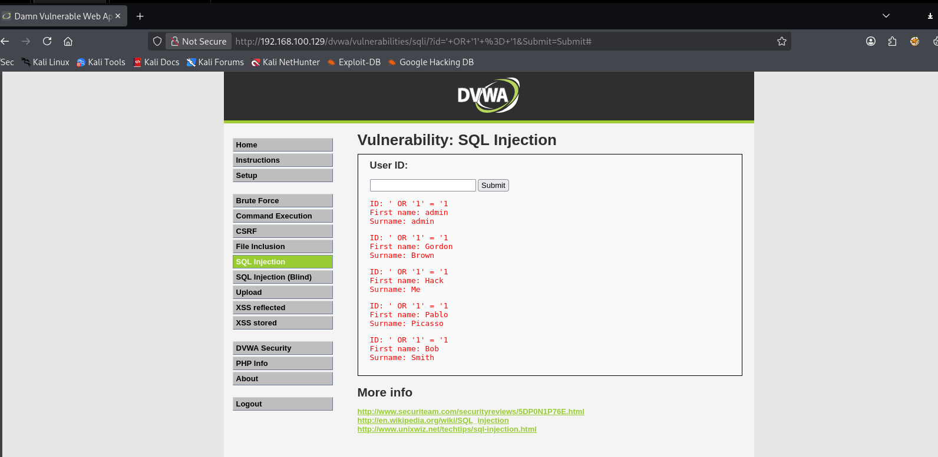

- SQL Injection testing
SQLmap was used to test for SQL Injection. The result was we were successfully able to enumerate the database.
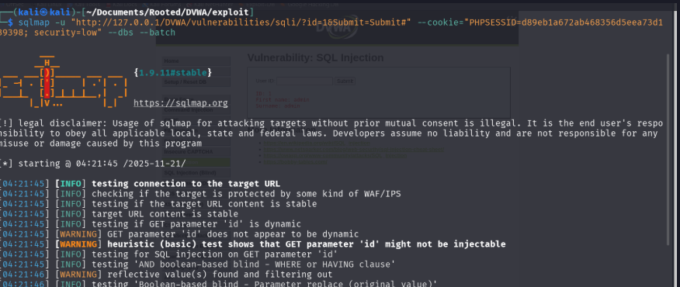

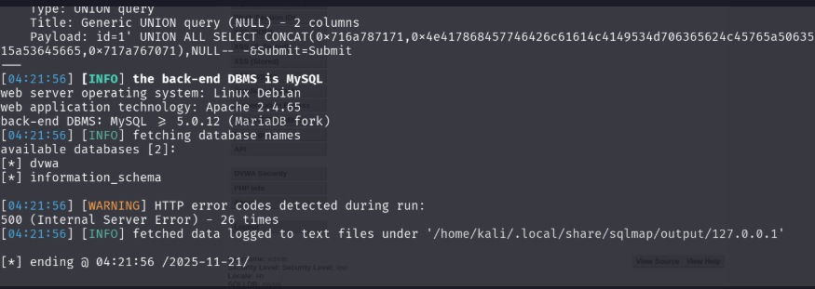

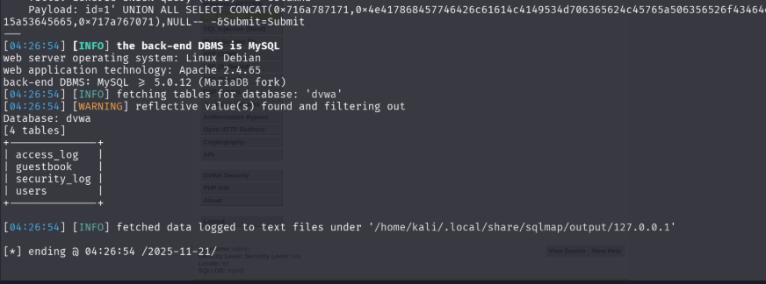

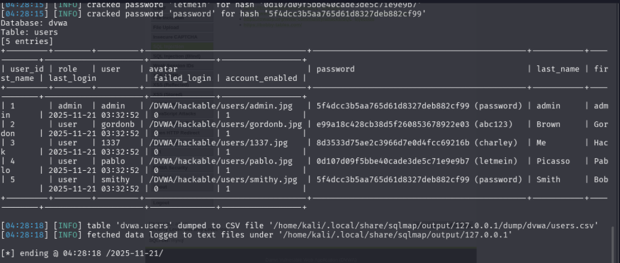

- Rate limiting & Brute forcing
The Endpoint /vulnerabilities/brute accepted unlimited attempts of login , demonstrating missing rate limiting protections.

API Testing Logs
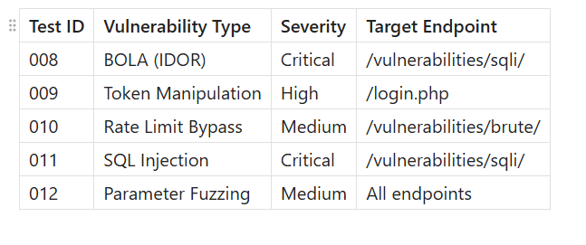
Summary
We were able to perform API Testing on the DVWA website which resulted in BOLA, SQL Injection, Weak session handling, and missing rate limiting controls. burp suite, SQLmap, were used to intercept traffic and extract databases. These vulnerabilities allowed unauthorized access, brute forcing/ dictionary attacks, full database exfiltration.

Remediation Recommendations
- Enable ACL level authorization for all IDs
- Enable rate-limiting which will prevent brute-force attacks
- Create new session tokens upon login
- Input sanitization on all input parameters
- Use prepared statements to prevent SQL injection
- Disable verbose error messages to prevent accidental enumeration.
- Implement proper authentication and logging

